`````````````````````````````````````````````````````````````````````````````````````````````````````````````````````````````````````````````````````````````````````````````````````````

Big Seas, Big Winds, Big Sky……

Big Adventure!

Boston, USA – Plymouth, UK

A Trans Atlantic Passage aboard Challenge Business #28

Paul G.R. Eatwell

I owe an enormous amount to many friends and colleagues who supported and encouraged me in taking on this challenge but I think the biggest mention must go to my Wife and Family. They had to listen to me bleating about one aspect or another of the trip for the over 6 months and singularly failed to point out the difficulties that they would face while I disappeared for the best part of a month.

I would also like to give a mention to my crewmates on the voyage – I hope that they got as much out of the trip as I did.

Skipper: Jon Crawford
Mate: John Quigley

Cowboys Indians
Garry Coaley Tim Ellis

Paul Eatwell Anne Massingberd
Sarah Ellis Colum McCoole
Richard Handy John McBride
Paul (Ace) Minost Willem Schenkel
Mary Yaros John Schirano

The trip in a nutshell…..

We Set sail from Boston at around 10:30 on the morning of 5th October 2002 and arrived safely (give or take a few cuts and bruises and 1 dislocated finger) in Mayflower Marina, Plymouth just after midnight on the 24th October.
We covered a total of 3,335.6 nautical miles in 19 days of sailing and experienced winds of up to hurricane force and seas of approximately 50 feet (peak to trough). We reached a top speed of 13.6 knots and our best day’s run was 228 nautical miles.

What type of boat were you in?

I was sailing aboard a 67’ steel yacht, Challenge Business #28 AKA "Invest Hong Kong".

How many people were there aboard?

There are 14 berths aboard, the Skipper and Mate (courtesy of Challenge Business) and 12 paying volunteers. This was not a cruise, we all pitched in and played a full part in sailing and maintaining the boat. Challenge suggest a minimum experience/qualification equivalent to RYA Coastal Skipper for this trip – I got the nod based on the sailing that I had done at college.

Who were the other people involved?

The crew were a real mixture - 3 girls & 11 blokes including the skipper & mate. The ages ranged from 28 - 50 odd and most people had either sailed with Challenge before or had their own boats.

What was the weather like?

We had a real mixture. At the start of the journey, we sailed through the dying embers of Hurricane Lili. This gave us wind speeds of up to 30 knots and quite a chop which caused a few problems with seasickness so early on in the trip. Later we had an extended period in high pressure systems with light variable winds but reasonably warm and clear weather. We also enjoyed several days of ideal sailing weather, consistently achieving boat speeds of 9 - 11 knots in 20 - 30 knots of wind (with gusts up to the mid 30s) while the weather stayed clear with occasional squalls.
The last week however saw us caught up in a complex sequence of low pressure systems giving winds of up to 65 knots (a Hurricane) and rain (occasionally heavy) for a time followed by a lull then gales for a period and then some more good sailing weather to bring us into the Western Approaches. The coldest night was the last one as we motored into Plymouth Sound at midnight on the 23rd October when temperatures dropped to 3 or 4 degrees.

How was the work organised?

We were organised into 2 watches, Cowboys & Indians, for ship handling and a "mother" watch to look after cleaning, feeding and watering each day. The ship handling watches were headed up by the Skipper and Mate and worked 6 on/6 off during the day and 4 on/4 off during the night, thus ensuring a rotation of watches and duties. Mother watch, once established, was handled in pairs with each watch contributing 1 member each day to clean the heads, pump the bilges, keep the boat tidy and look after meals, which were juggled around watch changes.

What was the food like?

We ate quite well (considering!). We had fresh meat for the first week or so and enough fruit to last us into the second week - this was augmented by canned and dried foods to provide plenty of variety over the 19 days - the emphasis was on getting plenty of calories into people.
We did have one experience of the dreaded freeze dried Chunky Chicken but mostly we managed with cans and packets bulked up with Smash and Uncle Ben's rice. Several varieties of ‘Cup a soup’ were generally the alternative if anyone didn't like the menu - everyone made a real effort to ensure that their colleagues got fed as well as possible.

It really is very tough to prepare anything when you are being buffeted around the galley as the boat cracks along at an angle of 25 - 40%, bouncing over Atlantic seas, banging knees, hips, elbows and backs on every conceivable corner and edge of the furnishings as you go. I think it's fair to say that whilst everyone appreciated the efforts of their peers, very few would opt for a repeat of the diet which we enjoyed.

How about the sleeping arrangements?

There were 6 cabins on the boat, 2 x 2 person and 1 x 3 person on each side. The watches were split to try and make sure that only 1 person was sleeping (or trying to anyway) in each cabin at a time.

A lot of people, hearing of my plans to take part in a Trans-Atlantic sailing voyage asked me why?

Personally, I blame the parents…….

I guess it all probably started with trips round Portsmouth harbour and visits to HMS Victory with the family while visiting Granny Southsea during the mid 60s. I also remember, about this time, reading of the exploits of Francis Chichester aboard Gypsy Moth, sailing solo around the world. I recall the jolt it gave to my imagination – I had no real idea just what he had achieved or what it had entailed but it certainly seemed like a big deal to a seven year old boy with dreams of the sea. Little did I realise at the time just where it might all lead!

I think though that the real “shaping” came as a result of my parents’ wanderlust and willingness to chance their arm. Back in 1967, there was a bit of an upheaval in Cippenham. For some strange reason, Mr and Mrs Eatwell had decided that bringing up 3 young children and looking after a large, energetic Labrador/Alsatian cross while holding down a job each was not challenging enough and that it might be a good idea to transport the whole shooting match some 7000 and odd miles to Cape Town, South Africa, just to make life a bit more interesting.

Things weren’t quite that simple though. There were also a few minor details to be sorted out like packing up the family home for transport to a new continent, informing, placating and reassuring various relatives, arranging visas, inoculations etc. not to mention arranging the logistics required in order to get everyone to Cape Town in one piece and in the right order.

So off we went – the family moved first to Southsea to stay with Granny and Georgie for a few days prior to Mr E flying off to Cape Town to establish a base for the tribe while the redoubtable Mrs E sorted out the simple problem of entertaining 3 very excited and inquisitive youngsters whilst saying goodbye to her Husband, her Mother and Father and I daresay experiencing a few nerves and traumas all her own.

Anyway, to cut a long story short, Mum and the youngsters were destined to follow Dad south via the Union Castle liner S.A. Vaal, the regular liner connection from Southampton to Cape Town, a not inconsiderable passage even then.

I found myself utterly enchanted by the trip, escaping from the nursery at the first opportunity and roaming the ship as far and wide as I possibly could, getting in to all sorts of scrapes but most of all just gazing out at the sea and thinking that this was a jolly adventure and a damn fine way to spend my time.

Then zoom forward to 1969, having crammed more into 18 months than most people do into a lifetime with various excursions around Southern Africa, friendships, accidents, medical emergencies and the rest, the family decided that it was time to head back to the U.K.

This time, we were all to travel together so once again we boarded the S.A. Vaal and set out for home. Once again, I was a little bugger, escaping at every opportunity to roam the ship and stick my nose into anything and everything – I had a whale of a time. Another seed was sown, I guess, reading about the exploits of Alec Rose in Lively Lady and his solo circumnavigation completed in 1968.

Back home, things got back to normal for a bit, back to visiting Granny and Georgie and trips round the harbour to see what the grey funnel line was up to. It’s around this time that the trip started taking a slightly different route with the guide pointing out Lively Lady – the yacht that had recently completed a solo circumnavigation under the guidance and care of Alec Rose. Another seed was sown in my young mind reading of the exploits of Robin Knox-Johnston, the first non stop solo circumnavigator who arrived back in Falmouth in 1969 barely 6 weeks after we returned from South Africa. I was only 8 at the time (nearly 9) – but I did realise that he had achieved something quite remarkable and I dreamed (as young boys do) of taking on similar challenges and sailing round the world.

Long years passed………
It took me a while to do anything other than talk about it but I did talk about joining the navy and sailing round the world on and off throughout my teenage years and eventually joined Britannia Royal Naval College in 1978 where I first set foot aboard a sailing craft. I know a Bosun dinghy doesn’t sound like much but it was my first experience of actual sailing and it was a blast – a screaming reach backwards and forwards across the river Dart with my bum dangling in the river – a real buzz. During my time at the college, I had a number of opportunities to learn more – sailing the college cruisers (Hurleys I think) and some time on the divisional yachts too but I also spent a fair amount of time messing about in motor boats – little things like HMS Hermes.

After leaving Dartmouth, it wasn’t until I went to college in Plymouth that I got back into boats. I suppose a degree in Nautical Science was a good place to start and in my first year I also completed the theory part for the Yachtmaster Offshore and my VHF license as well as joining the Ocean Youth Club. A friend at college invested in a Sonata (a 22’fin keel yacht), moored down on the Barbican and that was it really.

We sailed most weekends, I got involved with other friends in local racing in the Tamar, in the Sound and up and down the coast. Also, I did a couple of cross channel trips and at the end of our time at college, helped deliver the Sonata up to the Isle of Man. Apart from a few ferry trips and one tremendous afternoon sailing out under the Golden Gate Bridge in San Francisco Bay last year, that was me. I still hankered after the dream but family and work responsibilities as well as developing other interests meant that I thought less and less about sailing and did even less about taking part. Even the news that a friend of mine had invested in a yacht didn’t encourage me to stir my stumps and do anything about cadging a trip.

All that changed early in 2002 when I read an article in the Sunday Independent about taking part in the Atlantic Rally for Cruisers (ARC) race. It sounded like a tremendous idea, sailing from Gran Canaria to St. Lucia so I started making enquiries.

As it turned out, the race was quite expensive to take part in and the timings meant that I would have to take unpaid leave as well in order to do the full trip, Southampton to Gran Canaria and then Gran Canaria to St. Lucia. Being a bit naïve, I decided that just doing the 2nd leg wouldn’t be enough of a challenge and wasn’t really Trans Atlantic either – in fact I was thinking about just doing the 1st part.

Anyway, as I was saying..........

Then my Mum and Dad (Remember them?) spotted a competition in the Daily Telegraph to win a place on the Transat 2002 race being organised by Chay Blyth’s Challenge Business. I entered the competition and registered on their website and really thought little more about it – it was still just a dream – it just happened that I was more in the mood (given circumstances around my job at the time) to look to my own goals and ambitions.

Anyway, following my registration on the website, I received a copy of the Challenge Brochure including details of Trans Atlantic trips in 2001 and – as luck would have it – a flyer for some planned trips which included a small box in the bottom right hand corner:

A quick read of the brochure details and an exploratory letter detailing my experience to date (more out of date actually) and all of a sudden I was seriously considering it and several "shall I, shan’t I" conversations with my wife ensued. Julie eventually lost patience with me and told me to get my finger out and either get it sorted or stop talking about it!

So after a quick check at work to make sure that it was OK to take nearly 4 weeks off, that was it. I made the booking with Challenge Business on the basis of a £200 deposit and sorted out my visa for the USA. Then as soon as the issue of rationalisation and potential redundancy had been sorted out at work, I booked my flight to Boston and started calling on old friends to try and get out on a boat and start trying to remember which end of which bits of string do what.

First, I called Stuart who happily agreed to take me out for a weekend on Major Gamble, the MG 335 that he owns in partnership with his friend Ian, based in Largs. Luckily, I hadn’t forgotten everything and we had a great couple of days sailing in the Firth of Clyde – a gentle afternoon around the Cumbraes, through Inchmarnock Sound, moored at Tignabruaich overnight and then "shot" the Kyles of Bute in a force 4 – 5 for a bit of a buzz on the Sunday. A really nice re-introduction to life under sail and an affirmation of my resolve to go and "do" the Atlantic.

A few weeks later, we arranged a trip down to Southampton for a look around one of the 67’ boats. Jackie Shambrook from the Challenge Business arranged for the Skipper of one of the boats, Tim Greer, to meet me at Ocean Village on the Saturday morning (when he should have been at home I might add) to show me round his charge and answer myriad questions about the boat, the trip, the foulies etc. Tim was a mine of useful information on what to take.

I also got to try out the bunks (I’m 6’3" so it made sense to make sure that I fit!) and to see how much (or little) space I had to stow my belongings for the trip.

Stuart came up trumps again when he and his partner Rachel, invited me to join them on a trip bringing Major Gamble back into the Clyde after their week’s holiday in the Western Isles. Another 3 days of re learning was extremely useful, although Tim had pointed out that one of the hard things on the Challenge boats is getting people used to smaller boats to slow down a bit and remember the vast difference in weight, sail area and power involved in carrying out manoeuvres that they take for granted on their own boats.

I had a great time, sailing down from Crinan to Gigha on the Saturday, round the Mull of Kintyre to Lamlash on the Sunday (mostly motoring but still great fun) and then a gentle cruise back to Largs for a wash and brush up.

So that was it! I was as ready as I was going to get. Time to finalise my kit list and sort out a few last bits and pieces, get myself together and head off to Boston – Easy Peasy!

Getting Twitchy (A few thoughts penned in late September)……..

I have been waiting for this for a long time now. I made the original reservation back in April this year and organised my Visa straight away. It wasn’t until the final position regarding planned redundancies was made clear in June that I booked my flight and confirmed my place on the boat and I have been trying ever since to keep my excitement under control and attempting to stay focussed on the real world.

It’s been quite hard to stay focussed on “today” and not get totally tied up in the trip - I guess it’s been fairly difficult for family, friends and colleagues too. I have tried not to turn into a Trans Atlantic bore but it has been tough, especially with the Transat 2002 race to Boston going on - it’s been quite a moving experience, reading both the daily logs and the letters from crew members, relatives and friends, finding out how other people have dealt with and are dealing with the trials and tribulations of preparing for and taking part in this sort of challenge.

It’s been interesting to realise that those left behind are probably under even more stress given that they don’t have the visceral excitement of actually taking on the challenge to take their minds off things – they stand back slightly and see the risks, probably more clearly than I can or even want to.

The last few days though, it feels as though I’ve been turning into something of a drama queen, starting to look at the potential worst case. Not in a serious way – if I really thought that there was any likelihood of my not returning from this trip then I wouldn’t be going – but just enough to really start the adrenaline flowing. Anyway, the only way to avoid the risk is to not do the trip and frankly that is not an option, I would be absolutely gutted if anything were to happen to stop me going now. I’ve been building up slowly as I said, trying not to get too excited but it’s nearly here now and I am finding it very difficult to keep a lid on things.

I guess I should really be discussing this with my wife, but I’m a little concerned to open that potential can of worms – she hasn’t said anything to me so I guess she isn’t that worried and as I said, she probably realises that I couldn’t turn back now anyway. She has been supportive from the start and continues to deal with her new college course, the kids and the house while we wend our merry way through the myriad preparations necessary to get me to Boston ready to go!

And they’re off!

1st October 2002 – 05:00

Manchester Airport

Well I’m off, finally on my way to what I’ve built up now into probably my biggest undertaking so far – I’m not too sure that I really know just what I’ve let myself in for but it’s far too late to back out now.

I’m so buzzed (tired, excited, nervous and a whole lot more let me tell you) that I am actually feeling quite nauseous. It was very hard to say goodbye to Julie, Nat and Dom – I guess we were all trying to be brave – I only just managed to avoid tears as it was – I don’t think I would have held out if any of the others had started.

07:00

Waiting for the delayed flight, I got chatting to a young lady on the same flight who was on her way out to Accra in Ghana on a 5 month hospital placement. She’s on her gap year before taking up a place studying medicine and won’t see home, friends or family until March next year. It certainly put things into some sort of perspective – there was I feeling like a big brave boy, I’m awfully glad that I didn’t let on about my trip – her challenge seems rather bigger than mine.

2nd October 2002 – 00:30(BST) / 1st October 2002 – 19:30 (EST)

Copley Square Hotel – Boston Massachusetts

Well I finally made it!

It’s been a long day –
We were delayed at Manchester as the weather in Zurich (as it turned out – they certainly didn’t tell us what the delay was!) was not too good, we eventually took off at 07:55, this time I was really really on my way.

The approach to Zurich airport was great, though I think I must have been half asleep. There I was, watching the gentle rolling hills with the mist roiling about and then BAM! Those aren’t nice fluffy clouds above the mist and hills, they’re big hard mountains. It took a while to switch on but once I realised what I was looking at and concentrated on them rather than the lowlands it was quite breathtaking watching the sunshine and shadows playing across the slopes and peaks.

The landing was something else again! I spent last Autumn commuting to Paris and we had some fun (for fun read “interesting”) landings at Charles de Gaulle airport – dropping down through the clouds and wondering when/whether you would see the ground before you landed. But this was altogether different – actually descending into clouds when you can see hills and trees sticking out of the top of them – a real leap of faith! I’m glad they weren’t asking me to land the plane.

Anyway, by the time we eventually landed, I had missed all the connections to the USA and so was re routed via Heathrow. I didn’t really mind – at least I was still on track, all I had to do now was pray that my bag made it too.

I thought that I’d have plenty of time in Heathrow, given what they told me in Zurich – luckily I hooked up with another guy going the same route who suggested that we rush over to Virgin and get sorted and then worry about chasing bags. We only just made it. As we were queuing to check in, they announced that they were closing the flight so we hollered and they let us on but someone else turning up 5 minutes later was turned away – pretty close!

Anyway, we made it – from check in, straight through to boarding and now it was time to find out whether our bags had made it. I had taken the precaution of itemising every single piece of kit in order to replace it quickly if it got lost, but I really didn’t fancy that job. Luckily the baggage agent in the departure lounge was able to check – she had only received one bag from the Zurich flight and it matched one of our tags – mine. She wasn’t actually able to check the bag so we weren’t sure and we wouldn’t know whose bag had gone missing until we got to Boston.

We arrived in Boston at 21:30(BST)/16:30(EST) after a nice approach across the bay with lovely views of yachts and blue water. I experienced a vague sense of unease mixed with excitement, wondering if I might see our boat. After touch down and immigration which all went very smoothly, it was off to the baggage hall, praying that my bag was there and feeling guilty that my buddy would be the one to suffer if it was.

Well, my bag was there although it seemed a lot heavier than I remembered and I wasn’t looking forward to lugging it through Boston. My travelling chum left to make a claim on lost baggage and meet his ride, I headed off to the water shuttle that would take me in to Rowes Wharf and my first sight of the boat.

It all happened so fast, one minute I was peering out, trying to see where we were going, then there she was – Challenge Business #28 - Invest Hong Kong. A great opportunity for a “first sight” picture and I missed the shot! The water shuttle docked about 20 yards away from the boat, but on the other side of a pier and a dinner cruise boat. I walked round and got my photos, then shouted into the boat. John Quigley, the mate answered my holler and we had a brief chat – he seemed a little busy and I was starting to flag so I set off for the hotel.

Boston is in a real state just now, they are in the middle of a project called “The Big Dig” and the aim seems to be to disrupt all traffic, vehicular and pedestrian, as much as possible, whilst making as much noise and raising as much dust as possible at the same time. It certainly seems to be working!

I eventually got to the hotel, hot, sweaty, dirty and very tired but still buzzing. I certainly didn’t feel like sleeping but nor did I feel like going out and exploring – I was feeling rather lonely all of a sudden. Once again I was feeling that strange admixture of unease, nervousness and excitement, so I just settled down to watch some baseball and read my book.

So far so good!
2nd October 2002 (from here on in it’s all “local” dates and times)

I slept OK on and off – trying to avoid the effects of jet lag as much as possible. I tried to sleep in ‘til a normal Boston morning time so I woke up, read, dozed, woke up, read………….

I eventually gave up trying to pretend that everything was normal and went for a walk. I thought I’d try and find an internet café and a phone from which to call home.

Lesson 1 – Remember old lessons learned! I should have remembered the phone card that we used in California last year, I should have swapped mobile phones with Julie since hers is tri band, I should have set up a Yahoo eMail account.

I should have done all of the above, but I didn’t – I was too busy thinking about setting off.

Boston doesn’t do Internet cafes but I eventually managed to track down Kinko’s, a business services “shop” that sells computer and internet time. No luck with the phone, but I did manage to send off a quick eMail update to Julie and Mum and Dad.

I thought that I would be able to find a chain diner for breakfast but it appears that Boston doesn’t do breakfast – the streets are full of people munching bagels and carrying large coffee cups but I couldn’t find anywhere local to the hotel where I could get a decent breakfast. I eventually went back to the hotel and had a very agreeable mixture of fruit and fat. I started with grapefruit and followed up with corned beef hash (much more UK style corned beef than the stuff we had in California last year) and poached eggs, washed down with far too much coffee but hey! I needed fuel after yesterday.

I think it may have been a mistake not wearing socks with my deck shoes. I needed running repairs to some sore spots and blisters and then launched into my first pair of socks, a bit warm but a lot more comfortable.

My plan to wear the same clothes until I changed for sailing was already in trouble – I looked rather rumpled and felt a bit “grey” already and the forecast for the day was 30 degrees with 60% humidity. I started to rethink my strategy but had to beware as I had limited space to carry any extra baggage on the boat and no spare clothes with 3 weeks ahead.

Anyway, I took a cab down to Rowes wharf, having learned my lesson about lugging the bag last night, but there was no one at home. The skipper, Jon Crawford, was tending to his washing but saw me looking lost and came to meet me, then John Q arrived too. We had a quick chat and I offered my services but I think it would have taken them as long to tell me what to do as to do it themselves so that offer was declined, I was however invited to dinner that evening.

I asked the guys about sailing knives. As I intended to try and blag my luggage onto the plane as hand baggage, I hadn’t bothered to try and get one before leaving as I thought I might just cause some problems checking in for the flight or coming through customs. The Johns recommended that I get myself a good knife, if only for safety reasons when working on deck, so I stowed my bag and was despatched via the T (The Boston metropolitan transport system) to Eastern Mountain Supplies out by the University to pick up a sailing knife.

I really should learn to ask questions – I assumed since JC had recommended EMS, that they would know what I needed and he obviously assumed that I would know what to buy. Anyway I eventually managed to sort one out based on guesswork, intuition and some good advice from “Captain” Mike at the store.

The day had turned very hot and I was starting to really feel the pace, sore feet, tired legs and thirsty too so I checked out the aquarium down on the waterfront. Not a patch on the Monterey setup – well worth a miss – not even up to the standard of the Sea Life Centre at Rhyl.

Having killed a good ninety minutes, I set off back into town to get a couple more books and try to contact home again. I eventually managed to talk to a telephone operator who was prepared to tell me the international dialling code for the US – for information it’s 011 (Talk about lack of preparation – fancy not having checked that out before I set off!). She also informed me that I would need to pay $18.50 for the first three minutes of the call and that’s when I remembered the “calling card” that we had used in San Francisco – DOH!

Off I set to get a card and finally managed to make the call only to find no one at home so I left a message on the answer machine saying what our new itinerary looked like and when I might be likely to be able to call again and headed for the dock.

I arrived at the boat at around seven for dinner and just had time to get a clean shirt on before the guests started arriving. First to arrive were Amanda and Katie, two young ladies who had done a delivery trip with the Johns (John Quigley - JQ & Jon Crawford - JC) down to Port Washington on Long Island earlier in the summer and had obviously become fast friends with the chaps.

We had just been introduced when JQ received a call from some other old ship mates who were out sailing, asking if they were “at home” – about twenty minutes later, Max and Nick (both old Challenge hands) arrived alongside with two friends, Robert and Heather and JC swung into action preparing a very good fisherman’s pie. Bottles of wine and various drinking vessels appeared and the evening kicked off.

It felt quite strange at first, listening to their stories and comfortable banter but I was very quickly made to feel part of the group and several very lively conversations ensued. It seems something of a cliché – but it does seem that nice people meet nice people. Listening to Max and Nick talking about their Challenge Trips and hearing about Katie and Amanda’s experiences, it became apparent that they (we?) have a lot more in common than just sailing and adventure. There was a definite feeling of “like minds” with similar traits and approaches becoming apparent as we talked over a wide range of subjects.

It was great to see how well thought of the Johns were and to experience first hand, the challenge effect. It’s a fairly exclusive club (in the sense that there aren’t many members) but it’s not exclusive at all in the sense that I was made to feel completely welcome – lots of positive vibes about the trip ahead of me and encouragement to enjoy it all – as I said… Nice People!

We were joined late on by Willem Schenkel, one of my new crewmates. Willem is Dutch and had sailed several times with Challenge, completing a “Fastnet” voyage earlier in the year with JQ and a couple of the other Trans Atlantic crew.

I eventually hit my pit (upper bunk, forward cabin, starboard side) at about 12:30 AM looking forward to an early start and getting to meet my new crewmates.

3rd October 2002

Well, a nice early start – I was awake at 4 AM – obviously, I hadn’t quite adjusted to local time yet but at least I felt like I was getting there. My feet were still sore, a lot better but I was definitely looking forward to getting my nice comfy boots on and getting going.

I was really looking forward to meeting the rest of the crew. Having read the short bios sent to JC, there seemed to be a fair amount of “challenge” experience. 4 people had done the Fastnet with JQ earlier in the year and another 3 had recently completed a trip to Spitzbergen, north of the Arctic Circle. A couple of people had tall ships experience and everyone else had extensive sailing experience. I seemed to be the least adventure minded person there.

JC cooked breakfast for us. It was my first proper fry up of the year, what with my diet and all. Sausage, bacon, black pudding, white pudding, baked beans washed down with a nice glass of milk (I hadn’t drunk fresh milk since I was about 11 or 12 years old). I probably exceeded my weekly fat intake from the last six months in one plateful – absolutely smashing!

After brekkie, we took the mainsail off to check the battens, slides, reefing points and general condition of the sail – it seemed like a good idea with the prospect of 3,000 miles of sailing ahead of us. A good opportunity to learn a bit about how the rig is put together, figuring out what to undo and what to check for. A couple of screws on the batten boxes needed drilling out but we eventually triumphed and got the job done. We re attached the sail and tidied up the boom – job done (at least until we go sailing tomorrow, try to hoist it and watch it all go to rat s**t!).

People started arriving as we went through the day, everyone seems keen to get on with it now and enjoy the trip. JC set the briefing for 6 PM, so we all had a chance to relax a little bit and sort out last minute bits and pieces. I’m not a great one for omens or portents, but it turns out that I’m #13 – my bunk is number 13 and all my kit (life jacket, harness, foulies etc.) is numbered 13 and hanging on peg 13 – no problem – just thought I’d mention it.

I went into town with JC to Kinko’s, picked up a few eMails and bought some post cards for Dominic to show him what Boston looks like. I still couldn’t manage to contact home. No answer on home or mobile phones so I left messages saying that I’d try to call again on Saturday before we set sail.

The briefing was well received, JC gave us a bit more of a down to earth picture of what we could expect with an honest appraisal of the prospects for the weather, the hardships ahead but also about FUN. Everyone that I spoke to afterwards agreed that it was a good thing to discuss the likelihood of fear, sickness and fatigue and to deal with it openly rather than trying to pretend it was all going to be plain sailing. There’s a good feeling to the group, no prima donnas or drama queens, seems like a good balance of youth and experience and they’re all well “up for it”!

We headed out to Mr Dooley’s in the city for supper. Unfortunately we were all split up across 3 or 4 tables so there was limited opportunity to get to know everyone. My lobster didn’t live up to expectations either – a bit like farmed salmon i.e. lacking in flavour and texture but then only $8.99 per lobster, so I can’t complain too much.

Early to bed and early to rise, everyone is looking forward to a big day tomorrow – a chance to sail the boat and find out some of what we’ve let ourselves in for – Can’t wait!

4th October 2002 – Training/Shakedown Day

A nice leisurely start – we’re all still getting used to the idea of living aboard what is after all a fairly small boat for 14 people – so lots of polite queues for the heads and trying not to wake others up etc.

AM – Safety briefing

We got split up into watches – Cowboys and Indians – ready for watch keeping at sea, I was assigned to Cowboy watch along with Richard, Garry, Sarah, Mary and Paul under the watchful eye of JQ.

We had a quick run through of all the equipment above and below decks prior to setting sail this afternoon for a shakedown cruise out in the bay.

There seemed an awful lot to remember and it really started to focus me in on the scale of the challenge that we were all facing up to. Despite all their experience, neither JQ or JC had sailed this particular route before so we all had something new to look forward to.

I was trying very hard to keep a handle on everything that was going on but suffering a bit from a long standing trait of expecting to remember everything first time and get it right straight away – a touch of frustration started to creep in but I knew from talking to the others that I was not the only one struggling to take it all in. Time to chill out a bit and try to remember that we all have a lot to learn and a lot of time and ocean to learn it in.

PM – Shakedown cruise

Too many people, all wanting to get involved and have a go at everything. It’s all very well hearing about how to do something or watching someone else doing it but it’s rather different actually trying to do it.

Even things that I thought I knew are different or harder here – how and where to brace yourself when tailing on a line or to winch effectively – where to put yourself in order to get out of the way (or in the way) when necessary.

Evening

Well we’re back in port and the realisation is setting in – the next time that we rig fenders we’ll be tying up alongside in Plymouth. I’ve had a brief spell of wondering just what the hell I’ve let myself in for but a quick chat with Richard and Sarah helped me to put things in perspective. Sarah summed it up really well “I feel like I’m working with L plates on!”.
So do we all I suspect!

Anyway – off out to the Barking Crab for our “last supper” tonight, then up early tomorrow to try and contact Julie again to find out how she and Nat got on with their exams. Breakfast is planned for 8 AM and JC aims to set sail at around 10.

I’m still a bit concerned though, I don’t feel like we’re any sort of team yet. I hope that that will develop, it’s going to be awfully tough if it doesn’t. The group seem to share a number of similar character traits (we agreed on the term “boredom intolerant” as a good summary) and there are quite a few people with leadership experience which may make for an interesting period of negotiation and compromise before we get it right.

The Crab was quite good fun – a chance for a few chats about what we’re here for and the learning curve and range of emotions facing us. I stayed on for a few beers and met yet another Challenge old hand, Catherine. She’s done all sorts of trips including the TA and wants to go round the Horn next. We spent most of the time chatting about seeing the Tempest the week before with Derek Jacobi and seeing “Ken” (Mr. Branagh) return to the stage in Richard III earlier in the year.

It really is quite a club – the Challenge Adventurers – but not a clique at all. Everyone that I have met is really enthusiastic about the trips that they have done and come across as really supportive of those of us about to join.

The Big Day! (or should I say the 1st Big Day?)

Date | Day No. | Mid Day Position Latitude - Longitude | Day’s Run (nm) | Made Good (nm)
5th October 2002 | 1 | 42° 22’ N - 70° 46’ W | 15.5 | 12.6

And so the day has dawned – it’s really about to happen! I’ve just been up to the marina offices for my last 3S (S**t, Shave & Shower) on land for a while. I’ve tended to my various blisters, changed into fresh socks and pants and generally checked my bits – teeth, nails, etc. and made a really thorough job of it. I haven’t spent that long in a bathroom in years.

I rang Mum and Dad (still no joy at home!) – apparently I sounded subdued. I tried to explain that it was 6:30 in the morning and that I was in a marble tiled foyer, trying to keep the noise down but I don’t think that they bought it.

It’s true that I’m on the edge as it were, but I’ve had my doubts and got over them and now I just want to get started – I think we all do.

Breakfast at the Marriott was great – good food, good company, weather improving (the early drizzle and low cloud seems to be clearing and the wind is freshening too. We expect sunshine and 20 – 30 knot south westerly winds later.

I finally got hold of Julie and the boys. Nat passed his test and Julie’s exam went OK. Dom says that I should “only share my Marmite with my best friend on the ship”. I was really glad that I managed to talk to them all – it cleared my mind and set me up for the trip.

I honestly don’t know if it was the adrenaline or the hotel coffee but on the walk back to the boat, it felt like I was floating, I was buzzing so much. We’re all ready to go.

We finally set sail at 10:30 after loading a few last minute bits and pieces (like the freezer box). What a send off! The Johns have obviously made a big impression with lots of friends coming to see them off. A few of my colleagues had family and friends to see them off too and Max gave us a rousing chorus on the bugle as we cast off.

JC had heard that Clint Eastwood, Sean Penn & Julia Roberts were filming on the Tobin bridge so we took the opportunity to try a little product placement by heading up the harbour to the bridge and setting sail there to make sure they had a good chance to get us in shot – we’ll have to watch out for the movie to see if we made it in or not.

We tacked down the harbour and back past Rowes Wharf, got the boat up to 8.5 kts on a reach. JC tried to run down some poor unsuspecting crew taking part in a race – we were all shouting at him to head up to windward but he misunderstood us and steered to avoid a completely different boat. We finally luffed up and passed his stern by about 6 feet – what a start that would have been!.

The Cowboys lost the toss and the Indians have elected to take the first watch which means that we get to laze around this afternoon but won’t get to bed ‘til midnight.

Date | Day No. | Mid Day Position Latitude - Longitude | Day’s Run (nm) | Made Good (nm)
8th October 2002 | 4 | 42° 30’ N – 60° 58’ W | 150 | 130.1

Well so much for a day by day journal! The ship’s log will pretty much tell the tale of the tape and JC has offered to get us all a copy of that so I won’t have to remember all the details, just record impressions when I can.

Saturday night, it came on to blow as we hit the tail end of Hurricane Lili (or should that be it hit us?). Winds were 25 – 35 kts and by the end of the night we were sailing hard under double reefed main and #3 yankee. I got the first inklings of what lay ahead as we tried to sleep while the Indians carried out the sail changes, dancing on the deck about a foot above my head. We took over from the Indians at 4 AM with quite a swell running and several green people in evidence.

As dawn broke, we were still running into 25 kt winds but the sea state had eased considerably and we handed back to the Indians on a beautiful sunny morning and headed off for 6 hours in bed.
Note: “in bed”, not sleeping or resting. (It wasn’t 6 hours either! By the time we had changed out of our foulies, eaten and washed we had maybe 5 hours left and we needed to be up at least half an our before the watch change to eat and get dressed again).

By the time we had extracted ourselves from our foulies, I wasn’t feeling too good – not ill, just not good. I managed to get my head down eventually and felt OK but no real sleep, just dozing.

Back on watch at two this afternoon, lunch was pasta but I stuck to fruit and water, and a bit of helming and leaping about on deck. We spotted a few dolphins mid afternoon and I grabbed a few cookies and started to feel a bit better. By the time we came off watch at eight, I was ready for a couple of helpings of spaghetti bolognese.

Back on deck at midnight, still no real sleep, I’m only managing to doze and it’s starting to wear me down. Helmed a bit under the stars, but the watch passed in pretty much of a blur as the sea state started to rise.

I really wanted to find a way of explaining to people about helming at night. To try and explain the feeling of bowling along at 7 -–8 knots in a 40 tonne boat in the inky blue blackness of a mid ocean night, steering by a couple of stars whose name I hadn’t the foggiest about. Then watching (and feeling) the cross trees rise through their light as the boat is tossed skyward by a freight train of a swell that remained otherwise invisible as it passed by. It’s quite a feeling I can tell you – even better when you realise that all is well and that this is how it’s meant to be.

Back on watch at eight. These Indians really don’t know how to hang on to a good thing! We hand over fair winds and a well balanced boat and they feel the need find cross seas and more wind. This invariably leads to sail changes etc. accompanied by loads of banging and clattering about on the foredeck in the middle of our off watch rest – I wonder if they think the same of us?

I didn’t manage breakfast again – just stuck to fruit, as I’m not feeling 100%. Plenty of excitement to be had though, helming the boat under double reefed main, banging into 30 kts of apparent wind at 7 – 8 kts in 6 – 8 foot swell and occasional 12 – 15 ft seas. Really hard physical work trying to find the right line (failing miserably most of the time) and slamming the bow as we crest some very confused seas.

We hove to at one this afternoon – JC wanted to try and get some food into everyone and make a few running repairs. I managed the soup OK but the repairs proved more difficult.

We hoisted JC up the mast (no mean feat, the guy must be 16 – 17 stone) to try and sort out the mast head light, but we were rolling about too much for him to do anything so we lowered him straight down again. Meantime we slipped up and had to re set the #2 yankee and gybe so we could heave to properly again.

At one point, as we bounced on the swell, I ended up face down on the foredeck under a foot of water with no life jacket or harness – I was not amused.

We eventually set off again at about three thirty. We were due back on watch at eight with supper at seven thirty. Meantime the skipper changed course so that we ended up rolling like a log – not too good for my nearly settled stomach. I was going to go without supper as I still wasn’t feeling right but JC had threatened us all that he would start grounding people if they wouldn’t eat, so I forced down a bowl of rice and pork. I was really beginning to feel the pace and spent most of the watch trying to stay awake. I ended up dozing off down by the chart table whilst updating the log and when we came off watch I hit my pit hard!

I woke up at seven feeling like the proverbial box of birds and thinking I had an hour in hand before I was due on watch. So I bounced up, cleaned my teeth, had a wash, changed my base layer and headed for the galley. I decided to check out the weather and that’s when I realised I was in fact three hours late, the rest of the Cowboys were on deck and I had slept through the change of watches. No wonder I felt good!

The Indians had apparently managed to lose the wind altogether and we were motoring. I felt the only way to atone for the missed watch was for me to volunteer for mother watch and give JC and JQ a break – no one else had managed it so far so I wasn’t too sure that I was looking forward to it – but hey!

Anyway, I was really starting to feel good, like I was finally on top of the seasickness and adjusting to the sleep deprivation and exertion.

Date | Day No. | Mid Day Position Latitude - Longitude | Day’s Run (nm) | Made Good (nm)
9th October 2002 | 5 | 42° 39’ N – 56° 51’ W | 188 | 181.9

That’s my first go at mother watch out of the way. I think I had it easy – OK I was working by myself, but the boat was only moving in two directions at once while we were motoring - it was still “interesting”, cleaning the heads and the galley and (trying to) cook for fourteen. Anyway, I got it all done and nobody died!

We put the clock forward today for the first time, we’re now 2/3 of 1/3 of the way home. It seems to be very slow going with the unseasonal high pressure systems and light winds that we are experiencing making for very poor sailing. I had a purple patch on the wheel this morning, we managed 10.2 kts close hauled in 22 kts of apparent wind with the main reefed – I don’t think that’s too shabby at all.

Not a lot to add today. I’m starting to settle in to the rhythm of the trip. It’s still tough going especially getting the foulies on and off, but otherwise it all seems OK. I guess that may well change though, when the real North Atlantic October weather kicks in.

Date | Day No. | Mid Day Position Latitude - Longitude | Day’s Run (nm) | Made Good (nm)
11th October 2002 | 7 | 42° 20’ N – 49° 58’ W | 169.2 | 125.7

It’s all been happening here!

We abandoned the first waypoint and started heading straight for the UK – the weather is not helping us on our way at all. Light easterly winds and forecasts of more high pressure do not bode well for our progress. In fact we spent a long part of yesterday motoring into a 20 kt head wind in order to make significant progress – we are in real danger of falling behind schedule.

I overheard a discussion earlier regarding our water situation. Apparently there is a possibility that problems with the salinity sensor on the water maker may mean that we have to ration our use of fresh water in order to ensure sufficient supplies are available for cooking and drinking. A little concerning.

Overnight we have passed the “2000 nm to Plymouth” point. A stop in Ireland looks like a non starter now and we’ll need to push on in order to get a stopover in Falmouth in. Our current ETA is the 22nd.

A few personal high jinks this morning when it looked like I had blood in my urine. I mentioned it to a couple of the guys and the diagnosis is dehydration so I have been drinking a lot more water and things seem to have cleared up. Not a nice feeling though – knowing my body is not working properly but not being sure what is wrong - waiting to see if it’s anything nasty and wondering how we deal with it if it is, after all, we’re now out of range of any immediate assistance.

The challenge is not quite what I expected. We’re all getting along OK – no major dramas or any real problems though I think we all expect that things cannot stay this way indefinitely and sooner or later, we will get some extreme (rough, cold, whatever) stuff in the remaining 10 days or so. It seems we would all welcome something to write home about, especially now that we are all well and into the routine of things.

Date | Day No. | Mid Day Position Latitude - Longitude | Day’s Run (nm) | Made Good (nm)
13th October 2002 | 9 | 44° 41’ N – 43° 07’ W | 169 | 137.2

Day nine and we’re still not half way there yet. The weather picked up yesterday and we have at least had some sailing. Today has been quite good – even though we moved the clock forward another hour, we still covered 50 nm in the morning watch. Sarah set a new record with 11.3 kts sailing on a broad reach with double reefed main, #2 yankee and the staysail set, in winds gusting to 32 kts.

I got another good soaking today and have had to change into my number 2 mid layer as my track pants and fleece are soaked as are my gloves – it could be a cold one tonight.

I’m also still suffering the effects of dehydration. I’ve been peeing pink and passing what looks like coagulated blood – I really must keep up my fluid intake.

The watches have agreed that we won’t swap watch leaders (as was originally planned) so JQ is stuck with us for the duration.

We have had problems with the impeller on the engine cooling system, the water maker is still giving cause for concern, some of the hatches are leaking, we’ve lost a couple of sail track pins on the main, the mast head light continues to work intermittently, we have no instrument lights in the cockpit and now we have some sort of gas leak from the bottle. We really must be pounding the boat at the moment. 20 – 25 kts wind and 8 – 12 ft swell sets may make for interesting sailing but it does seem like a lot has gone wrong with the boat this trip.

The weather forecast is for more of the same as we play catch up with a low pressure system heading east although it is expected to fill and disperse as we catch up with it and we may end up becalmed again. Our ETA is still 22nd,23rd Oct.

The Challenge Transat 2002 race should have finished by now but we have no news of placings. We have been eMailing head office fairly regularly during the trip, asking for assistance with the technical problems that we are experiencing but have not received a lot in reply.

A fourteen day crossing for the leaders is none too shabby, it certainly doesn’t look like we’ll be challenging that or trying to catch up with the tail of the fleet – we’re heading for seventeen or eighteen days (and that on 120 miles less distance!)

Tomorrow should see us reach the half way point – time to get the cake out and think of home, if only for a short while (some friends gave me a “Bole de Miel” from Madeira to celebrate the half way mark with).

I guess that time will pass a lot quicker on the down slope – there will be some who are only too glad to finish the trip and get back to terra firma and civilisation. Me? I don’t know! Yes I’ll be glad to have “done it” and of course I look forward to seeing everyone again but I have enjoyed the trip so far. It’s been hard work adapting to a different regime but kind of refreshing to have no extraneous pressures or problems, just keeping the boat moving and staying warm and well.

Half Way Day!

Date | Day No. | Mid Day Position Latitude - Longitude | Day’s Run (nm) | Made Good (nm)
14th October 2002 | 10 | 46° 15’ N – 39° 11’ W | 204.3 | 161.8

We actually went under the “1500 nm to Plymouth” mark in the very early hours of this morning but to be honest, we don’t know what “half way” should be so we held on ’til noon to celebrate.

I broke out the Bole de Miel, courtesy of Steve and Janet, and handed it round. The cake was very very rich but it seemed to go down OK and everybody had a piece.

I got a couple of pictures of me juggling in the middle of the Atlantic for my web site – the swim was a non starter though.

It’s now getting kind of hard. We’re all struggling on the far side of knackered. Sleep deprivation is starting to take its toll and we’re all working very hard when we’re awake too.
Today is my second mother watch – I’m working with Big John McBride and we’ve scrubbed, cleaned, swept, pumped and cooked and we still have more to do plus dinner tonight.

I mentioned earlier that it’s getting hard. We sailed through a full on gale last night. After changing down to the #3 yankee and putting the second reef in the main, the Cowboys set a new speed record of 13.6 kts with Richard at the helm in winds gusting over 35 kts. The boat was surprisingly easy to handle but it was quite a ride.

We now start counting down to Plymouth (or wherever) and that’s tough too. The greater distance of the journey is behind us but the challenge starts here. The weather picture is unclear but there are gales over the UK and a developing storm south of Ireland with several “spin off” lows about. We could end up getting really hammered at the last – we’ll see.

It’s strange to think that in ten days it will all be over and we’ll all be heading home again. I wonder how things will have changed in our absence, maybe not at all. Maybe it will be us that have changed the most.

Anyway, plenty to look forward to before then. We need to make the most of it and have a ball!!

Date | Day No. | Mid Day Position Latitude - Longitude | Day’s Run (nm) | Made Good (nm)
16th October 2002 | 12 | 47° 35’ N – 29° 26’ W | 220 | 210.2

We’re well on our way now with <<1100 nm to run and we expect to be under the 1000 mark by noon. We covered 226 nm (23:00 – 23:00) yesterday with 194 & 195 the previous two days. The weather is expected to moderate today and build gently to a decent south westerly blow in the next two to three days. There is still the chance of getting caught by a storm developing south of us as it moves past us into the channel. The weather pattern is quite confused and things are not developing according to expected patterns for the time of year.

Yesterday was a spanking day’s sailing, averaging 10 knots on a beam reach in 25 –35 kts apparent wind. I managed a new personal best of 10.9 kts but no one has come close to Richard’s record 13.6 kts.

More problems with the boat. We had to replace another impeller which leaves us with just one spare and the gas is now switched off between meals as the leak remains and we’re down to our last cylinder.

The wind is starting to veer ahead of us as we move towards a high pressure system.

Later….

We started the engine to heat some water and by the sound of it we just wrecked our penultimate impeller so even when we replace it, we will have to be awfully careful about using it. All sorts of potential problems now in the event of man over board, dismasting etc. as any accident would leave us very exposed – not to mention potential problems berthing in Plymouth.

We’re all getting tired and damp now and we can begin to see the end in sight so we’re starting to think of warm dry beds and home comforts. There is still plenty of sailing to do though and plenty of landmarks to pass, Bishop Rock light, the Scillies, Wolf Rock, Land’s End, the Lizard, Rame Head, the Sound. The last time I saw most of these was sailing up to the Isle of Man with Niall back in 1986.

There was some discussion after dinner last night about “what next”. The 2004 Global Challenge is full but JQ says that there may be “legger” berths available, though he did warn of the issues associated with being a bit player in a big team venture like that. Plus am I ready for a race, especially one on that scale? I’m not sure.

The Fastnet race is a possibility but certainly not next year. It seems like a good idea to do a short race to see if I can hack the required behaviours and then maybe think about 2008? I still want to do more sailing providing I can fit it in with everything else – family, work etc. I reckon that I can hack the voyage pace, but it’s a question of finding the right one. Round the Horn? Cape Town in or out? I don’t really know but I don’t think I’ve finished.

I’ve just heard that we’re due another clock change today, so we’ll only be “BST minus 2” by lunchtime. It really feels like we’re starting to close this out but we need to stay alert and remember that it’s not over ‘til the fat lady sings!

Date | Day No. | Mid Day Position Latitude - Longitude | Day’s Run (nm) | Made Good (nm)
17th October 2002 | 13 | 48° 16’ N – 26° 36’ W | 160 | 109.6

After minor alarums overnight with the engine once again (It feels like we’ve lost all faith in it now) and a heavy morning beating in to 25 – 30 kt winds and barely making east north east, it has now been definitely decided to head for Plymouth. Kinsale was a potential emergency bolt hole even up to midday today but JC & JQ are happy that we can beat the impending storm into the Western Approaches without too much trouble and that the engine looks good enough to get us alongside.

We still have issues with gas and the galley sink pump seems to have packed up but we soldier on regardless.

I’ve just noticed on the chart that several features on the Rockall Plateau share names with places in the Lord of the Rings stories, Fangorn, Rohan, Lorien, Eriador and Gondor. I wonder which came first and are there any more?

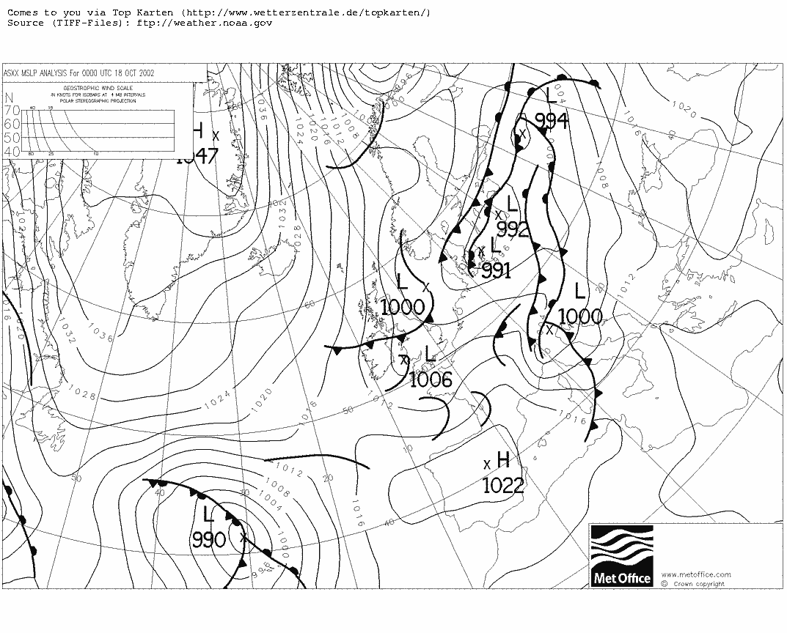
Looking at the weather fax, this storm looks a doozy. Winds of 55 – 60 kts about 100 nm from the centre are forecast for extreme West Biscay at midnight tomorrow night. It should pass to the south of us, just leaving us to play in the northern edge as we head into the Western Approaches – it promises to be fun.

We’re closing with Plymouth at 5.3 kts and our ETA now is AM on the 21st. At this rate we’ll be up to the Scillies some time Sunday morning. People are starting to get excited about the end now. Me? I’m having mixed feelings regarding completing the challenge, getting home, wanting more, counting my chickens and waiting for the fat lady to give forth.

Date | Day No. | Mid Day Position Latitude - Longitude | Day’s Run (nm) | Made Good (nm)
18th October 2002 | 14 | 50° 24’ N – 24° 28’ W | 184 | 72.1

Another long night – we covered the 8 – 12 and 4 – 8 watches. Lots of wind shifts in generally light winds with slow progress northward. We’re still only just on a level with Land’s End.

A sobering announcement at breakfast as the skipper told us that the low pressure system hasn’t moved as forecast, is deepening further and moving north and that we can expect wind speeds of 60 kts in the next twenty four hours. Looks like we’re all going to get a bit more excitement after all.

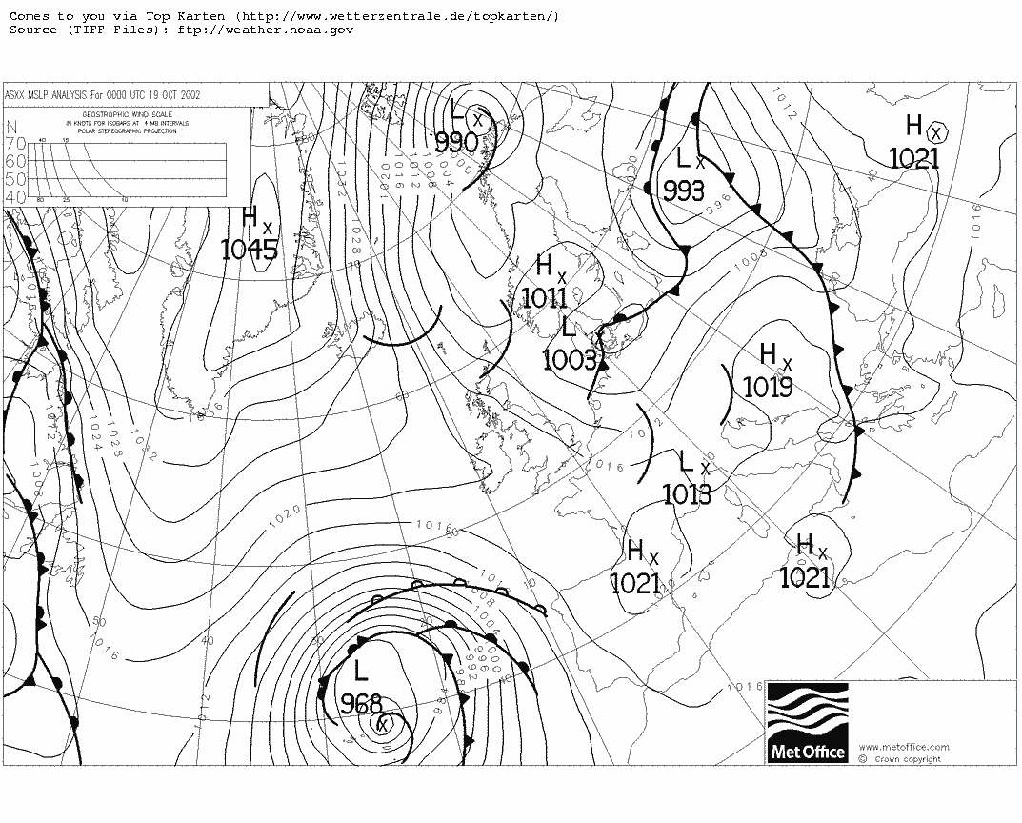
We are now in the process of tidying all the loose kit away and preparing storm canvas etc. We’re making sure that we are rigged (or ready to rig at short notice) for storm to hurricane force winds. I really need to try and get some archive weather charts for this trip when I get back. I’ll need them to try and show the patterns of developing weather that we have had to try and predict and deal with during the trip.

Lots of reassuring noises being made about how the boats were built for this sort of weather and how they’ve been through it before etc. I think most people are more concerned about how they/we/I will deal with it. I know I’ve seen storm force winds in the Bay of Biscay before, aboard Hermes and the Bilbao ferry but I think this will be quite different. The idea of “batten down the hatches and ride it out” seems a bit passive to me. I’m not sure how I’ll deal with my own worries, let alone anyone else’s.

I wonder if anyone at home has been following the weather and realises that we’re for it? I hope that they’re not all worrying too much – it strikes me that the thought of it for them could be worse than the reality for us.

Anyway there’s no certainty that we are going to get hit – we’re definitely in for a bit of a blow and an interesting couple of days. I guess I’ll enjoy talking about it and making up “what I was thinking” stories afterwards but to be honest I’m not thinking about it, I prefer to deal with it if and when it happens.

Date | Day No. | Mid Day Position Latitude - Longitude | Day’s Run (nm) | Made Good (nm)
19th October 2002 | 15 | 50° 27’ N – 22° 08’ W | 180 | 88.9

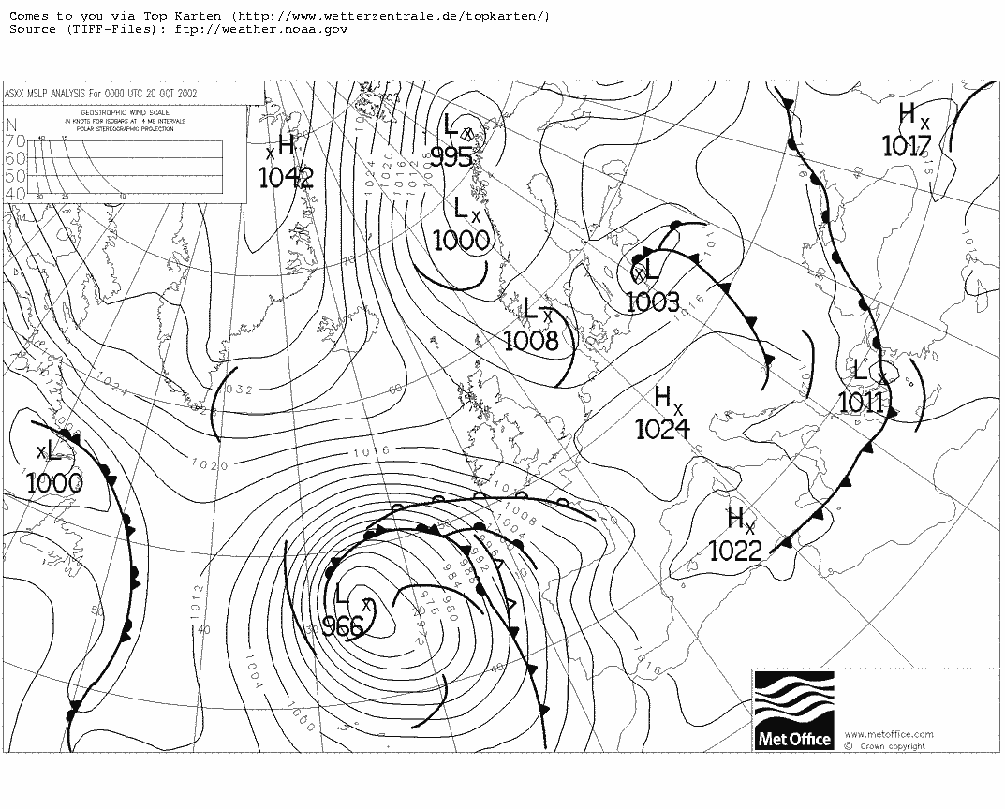

Big seas and big wind. I was really struggling on the helm, fighting the boat and finding it very difficult to see for the spray being blown into my face. Richard came to the rescue, bracing himself against the wheel guard in order to act as a human shield, taking the worst of the wind and spray on his back so that I could steer. JQ said that we should go turn and turn about, completing thirty minutes on the wheel, thirty minutes as the shield and then thirty minutes below to warm up a bit.

It was quite something to steer the boat up the face of really big waves. Being able to see wave face ahead of the bow and behind the stern on a 67 foot boat, that’s quite a long wave face. I would guess that we were looking at wave heights of maybe 50 feet, peak to trough – they were certainly intimidating even though I never felt that the boat was under any threat. It always felt like it was “on top” of the seas and probably handling it better than I was.

On my second go round, as I climbed round to take over the helm from Mary, while JQ was acting as the human shield, I was knocked over by a wave and swept from one side of the boat to the other, just barely missing Mary’s head as I went by. I landed heavily on the other side of the cockpit, banging my head, knees, hands and ribs as I landed on the leeward deck gear. Luckily, I was clipped on and was never in any real danger, but the incident had a profound effect on the rest of my trip even though it was really my confidence that was shaken more than anything else.

I was sore all over and soaked too but it didn’t seem that bad and everything was working. I sat down in the cockpit to gather myself and started to feel OK. I took another soaking shortly after as another big wave broke over us just as Garry came off the wheel – it was quite a shock to see him heading backwards off the leeward cockpit seat – thank heavens for lifelines.

Eventually though, it was felt that we just couldn’t hold a course and the skipper decided that we should heave to and sit it out for a while – all of a sudden it didn’t seem too passive any more.

My lowest ebb….

Having been knocked off the side of the cockpit and banged about and soaked, I was feeling a bit bruised and rather nervous and very wet, but otherwise OK. My real problems started when we decided to heave to and I went below to get changed. That was when I realised that I had split my shin. I don’t remember banging it on anything, or it even being very sore – it was my wrists, shoulder and ribs that were tender but when I took off my long johns and saw the gash and the blood, I had a real shock. I thought I may have landed on the bow in the drawstring of my wellies and had it pushed into the shin, that’s the sort of shape that it was but whatever had happened, I knew it wasn’t very good.

I started to get a bit worried, I knew it wasn’t just a scratch but I didn’t know how bad it really was and who to talk to or what to do. I asked JQ to bring the first aid kit hoping that he might ask me what I needed it for and take a look and maybe offer a bit of reassurance, but I didn’t say anything about how worried I was by the size of the cut or the amount of bleeding. It all seems a bit childish now but at the time I felt very low. Anyway, I eventually brought myself to clean the cut with antiseptic and put a dressing on it and got the bleeding stopped but I spent the night laid in my pit wondering if I should tell someone and what they might do (or even be able to try and do). I decided to keep schtum and tried to convince myself that if I could just take a rest, everything would be OK. The bad part was lying in my pit feeling cold and lonely. Still it took my mind off the weather!

Date | Day No. | Mid Day Position Latitude - Longitude | Day’s Run (nm) | Made Good (nm)
20th October 2002 | 16 | 49° 47’ N – 21° 09’ W | 88 | 42.3

Well morning came and we set off again, then JC came to wake up the Cowboys for the watch change. I eventually worked myself up to ask for a rest, saying that I was a bit shook up and wanted to take a break. JC gave me a bit of a lecture, telling me in no uncertain terms that this was no time for anyone to stop pulling their weight – things were tough and we all needed to work together. I still couldn’t bring myself to explain my worries over the cut so I just took it on the chin, got myself dressed and joined the rest of the watch on deck. It was pretty hard going, but I’m glad Jon made me look at the situation and deal with it. I can look back at a tough time personally and think to myself “I did it!”

As it turned out, it was quite a quiet day, motoring to windward with storm canvas set. We didn’t really get going until the afternoon and by that time I was over the collywobbles and pretty much back in the groove. I was till shaken and sore, but the going was easy enough.

Date | Day No. | Mid Day Position Latitude - Longitude | Day’s Run (nm) | Made Good (nm)
21st October 2002 | 17 | 49° 20’ N – 17° 22’ W | 159 | 150.1

Just when you thought it was all over…..

After a quiet night of decent sailing, things started to build up again, with winds in excess of 25 kts and some more big seas and spray. It was a big big rush (with very wobbly knees), taking over the helm and driving the boat. Again, at the time, I wasn’t totally sure that I wanted to be doing this but looking back, I was awfully glad that I did! Nothing too silly or daring, but taking my turn and getting the job done was quite an effort.

I was quite glad to hand over after thirty five minutes but I was still there to take the next turn if/when required. I’m sure no one else gave the conditions much of a thought but I sure did and the watch change at lunchtime was very welcome. The last couple of days has really taken it out of me and I needed to try and get some sleep and recharge my batteries.

Date | Day No. | Mid Day Position Latitude - Longitude | Day’s Run (nm) | Made Good (nm)
23rd October 2002 | 19 | 49° 46’ N – 06° 39’ W | 228 | 213.6

Well, this is it – we’re on the last leg. We expect to see the Bishop Rock mid morning and be in mobile phone range by early afternoon – if all goes according to plan, we should be alongside in Plymouth tonight.

Fired up the mobile to call Julie and check out train times for the journey north. Surprised to get a text message from Brian welcoming me home – how does he know?

Anyway, I called Julie to get her to check out train or bus times – I was still expecting to be making my own way home. It turns out that she and Dom are sitting on Plymouth Hoe – they did manage to come and meet me after all – really great! Our ETA is probably eleven or twelve tonight so she needs to get Dom to rest this evening if they’re going to actually see us dock. I can’t wait to see them, the prospect of having them there to meet me makes all the difference. I really wasn’t looking forward to the anti climax of arriving home on the train or whatever, now I get a proper homecoming - Brilliant!

Creeping into the Sound under cover of darkness seems something of an anti climax – the engine is holding up though. Coming alongside in Millbay, we can’t even get hold of anyone in the marina to tell us where to tie up so we’re just heading for the end of one of the pontoons.

Date | Day No. | Mid Day Position Latitude - Longitude | Day’s Run (nm) | Made Good (nm)
24th October 2002 | 20 | 50° 22’ N – 04° 10’ W | 109.6 | 81.8
Total |  |  | 3335.6 | 2724.9

00:30

We’re in! Seems like a lot of people have made the effort to meet us – we tied up alongside another boat so it’s difficult to see who’s on the pontoon. I leapt ashore and found Julie and Dom on the pontoon – a chance for a big hug and then JC gave us the rest of the night off – he’s all heart! We have to be back for nine in the morning for breakfast and to clean up and de store the boat.

Back to the Saltash Travel Lodge, a good scrub and a bed that doesn’t move or poke you in the ribs – heaven.

Later…..

Julie dropped me off back at the boat and headed off. We headed round to a greasy spoon, in Stonehouse, down by the Cremyll ferry for a full on fry up – we had been talking about this for days and it certainly lived up to expectations – brilliant!

Then it was back to the marina and down to work on the boat. The plan was to finish up at lunchtime, grab a quick beer and some team photos and then head for home – Colum had already left for London and Willem left last night.

We finished sorting out the boat and settled down to our beers and Tim did a quick presentation to JC and JQ. I just had time for a couple of photographs and then it was time to head home. I was still walking on wobbly sea legs and very very tired.

25th October 2002

Well we made it home at about eight last night after a 5 ½ hour drive from Plymouth. A big hug from Nat followed by a large Penne Amatraciana and half a bottle of a very nice Valpolicella Ripasso. That saw me off to bed for a long sleep but it didn’t quite work out that way as my body seems to be accustomed to sleeping in short snatches. I think it’s going to take a while to get back to normal.

I think it’s also going to take quite a while to really come down and get round to finishing off the story. It’s quite easy to answer specific questions and tell bits of the story but I can’t really get my head round the whole thing at all – maybe it’s just too big an experience to “summarise”.

It’s great to be home and back with the family but it seems nothing much has changed. Already, it seems like a long time ago and a long way away. I’m already back at work and dealing with the same project issues that I was dealing with before I left. I guess I’ll just have to take my time and see where it all goes.

28th December 2002

It has taken me a lot longer than I thought to finish this journal. I kept putting it off, thinking that I needed some profound insight or great truth to draw the story to an end. Well it hasn’t happened. I’m back at work and back in the old routine at home, nothing much seems to have changed.

If I have one regret, it’s that there wasn’t time on the trip to get to know my crewmates better. The two watches hardly spent any time together and even on the same watch, we were generally focussed on getting along and getting the job done.

I came back thinking “I couldn’t go through that again”, but now I miss it and can’t help but think that I want to do more. This trip was something special, something personal, but it seems to belong to another time, another life almost. The time out on the ocean was very precious, I can’t describe it, or at least I don’t feel that I can do it full justice. All I can think of to say is that it was big,

Big Winds, Big Seas, Big Sky………..Big Adventure!
Kit List

Sleeping bag  Fleece camping pillow  Microfibre towel  Head torch  Binoculars  2 X waterproof disposable camera  Digital camera with 64 MB flash card  1 Pr Rayban Wayfarers  1 Pr Rayban Aviators  2 X 9 pack AA batteries  1 X PX28L 6 Volt battery  1 Doz self heating “hot pads”  5 X Gel writer pens  1 X Hard back A4 notebook  Juggling sacks  Nappy Sacks  Travel “Space” bags - compressible  Waterproof pouches  Ziplok pouches  Toiletries  2 X Ventolin Inhaler  1 X Flixotide Inhaler  Silensor snore Guard  Simple Shower Gel  Toothpaste  Toothbrush  Mini Shaving Gel  Concentrated Anti perspirant  Razor  Dental Tape  Multivitamin Pills  Omega 3 fatty acid capsules  Ginger capsules  2 X 64 pack Huggies alcohol free baby wipes  Travel wash detergent  1 small tub vaseline  1 tube Haemmacaine  1 Tube 1% Hydrocortisone cream  1 Tube Ralgex  1 pack Hypo allergenic/antiseptic sticking plasters  1 Pack Immodium  1 pack Sennakot  1 pack Kwells  2 X Sun Cream – Hypo allergenic factor 15  2 X Sun Block sticks – Hypo allergenic factor 25 | Clothes  Gill Sailing Wellies – European size 42  Gill “Championship” kevlar palm fingerless gloves – Medium  Gill “Helmsman” kevlar palm, windproof/waterproof gloves – Large  Heavy duty “Thinsulate” gloves  Musto fleece lined cap (with ear flaps)  Woolly hat  Baseball cap  Lowe Alpine “ear gear”  Regatta neck gear  Field and Trek neck gear  1 Pr Track shorts  1 Pr Track pants  1 Pr Ron Hill Trackster - Lycra pants  1 Pr “Buffalo” Pertex salopettes  2 X fleece shirts  1 Karrimor “Typhoon” wind stopper fleece jacket  2 X Helly Hansen base layer long johns  3 X Helly Hansen base layer vests (long sleeve)  2 X Field and Trek base layer T shirts  1 X Lowe Alpine “Active” T shirt  3 Prs M & S Microfibre briefs  3 Prs M & S Sports support trunks  6 Prs M & S Anti Bacterial sports socks  5 Prs Microfibre walking boot socks  1 Pr Speedo swimming trunks (well you never know!)  This was augmented in Boston by another microfibre T shirt and a sailing knife.  I could have done with another change of base layer gear for comfort but I was pretty “ripe” by the end anyway – thank heavens for baby wipes!  The real stars were the Pertex salopettes, the head torch and the Musto hat.
Challenge Business International Ltd.
Building S115
South Yard
Devonport Royal Dockyard
Plymouth
Devon
PL1 4SG

Please find enclosed, my completed booking form for voyage TA1, Boston to Plymouth, October 3rd 2002 – October 24th (ish) 2002.

As requested, here is a brief summary of my sailing experience:

I started sailing in 1978 when I joined the Royal Navy and sailed as crew in the college yachts on several trips during my time in BRNC Dartmouth.

I moved to Plymouth in 1983 to take my degree in Nautical Science at Plymouth Polytechnic (Now the University of SW England) and during my time there (1983 – 1986), I completed my RYA Yachtmaster Offshore (theory part). My sailing experience during that time involved numerous coasting trips, some club racing and some cross channel trips as well as some time in Falmouth Packet, the OYC boat. The longest single trip was a 2 handed delivery of a friend’s Sonata from Plymouth to the Isle of Man calling at Sennen and Holyhead.

I have not sailed since 1987 but am confident that I am sufficiently fit to play a full part in the voyage and although I may be a bit rusty to begin with, I have sufficient background to enable me to get up to speed quite quickly and that I have sufficient grit and determination to see this challenge through.

Regards,

Paul G.R. Eatwell

Challenge 67ft Race Yacht
From 1990 to 1998, Challenge Business oversaw the design, build, fit out and maintenance of their fleet of sixteen 67ft Challenge Race Yachts. During that time the fleet sailed well over 1.5 million miles including 24 fully crewed circumnavigations against the winds and currents (the 'wrong way') in the British Steel Challenge 1992-93 and the BT Global Challenge 1996-97.

In addition both Mike Golding and Samantha Brewster have sailed 67ft yachts around the world single handed following the same route. Mike Golding's voyage was non-stop and Samantha Brewster made one stop.

The yachts were built by Devonport Yachts in Plymouth. They are very strict one-designs. Because of the one-design nature of the yachts and therefore not as much of a limiting factor on weight, the boats are fitted out to a standard that required no refitting for corporate or adventure sailing use.

The 40 tonne Global Challenge Race yachts, made of British Steel, were originally designed for the rigours of the Southern Ocean. Having raced tens of thousands of miles in the toughest and most demanding oceans they have certainly demonstrated their outstanding seaworthiness.

The comfortable and heated accommodation berths fourteen, (two three-berth and two two-berth cabins forward and two two-berth cabins aft). The cabins are more inviting than on most ocean racing yachts and each bunk has a full length pipecot with a deep leecloth. There are two heads (toilets) on board each fitted with a hot shower. A table around which the entire crew can sit dominates the spacious saloon.

For corporate sailing the yachts carry twelve guests, plus up to four crew.

Length overall | 67ft 0in | 20.42m
Length waterline | 55ft 0in | 17.76m
Beam | 17ft 3in | 5.26m
Draught | 9ft 3in | 2.82m
Sail Area | 1932 sq ft | 179.49m2
Berths | 14
Designer | David Thomas

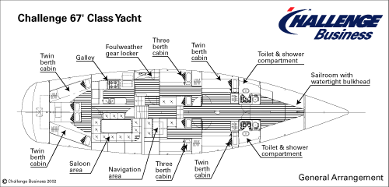

See details on page 31 – Courtesy of Challenge Business
See experience letter on page 30
A colloquial term for the British Royal Navy
See page 29 for my complete kit list.
For info: 1 nautical mile is equivalent to 1.15 land miles or 1.85 Kilometres
Changing in and out of foul weather gear was “interesting” throughout the trip. Several people (sometimes tired, sometimes queasy) trying to don salopettes, jackets, lifejackets etc. and get on deck quickly at the same time in a very confined space calls for some very careful manoeuvring and a fair amount of co operation.
It’s not on the chart but there is apparently also a Gandalf Spur nearby. They were named after the places in J.R.R. Tolkien’s Middle Earth but I haven’t been able to find out when or by whom.
The weather charts included in this journal are not the same as those we received on the boat. These are surface analysis charts from the British Met. Office Archive, the ones on the boat were forecasts provided by the US Met. Office.
I managed the rest of the trip with various applications of antiseptic, field dressings and at one point even gaffer tape to hold the damn thing in place and try and reduce the rubbing of my wellie boot top over the cut. On my return to the UK, I saw a doctor who said it was far too late to stitch it and prescribed anti-biotics to deal with the infection which cleared up within a week or ten days. The cut itself has pretty much healed up but has left a rather ugly lump (or interesting battle scar!) on my shin.

